**Software Testing Assignment**

**Module 3**

**1) What is RDBMS?**

* **RDBMS**: A database is an organized collection of data stored in a computer system and usually controlled by a database management system (DBMS). The data in common databases is modelled in tables, making querying and processing efficient.

**2) What is SQL?**

* **SQL: Structured Query Language**andis a computer language that we use to interact with a relational database.
* When data needs to be retrieved from a database, SQL is used to make the request.

**3) Write SQL Commands?**

* SQL Commands

1. **DDL** = Data Definition Language  
2. **DML** = Data Manipulation Language   
3. **DCL** = Data Control Language   
4. **TCL** = Transaction Control Language   
5. **DQL** = Data Query Language

**4) What is join?**

* **JOIN**: The SQL joins two tables based on a common column and selects records that have matching values in these columns.

**5) Write type of joins?  
1. Inner Joins** = Inner joins are the most commonly used. They only combine records from the two tables if they both match the join condition (share a common attribute).This joins work best when referential integrity is enforced in the database, especially on primary and foreign keys.

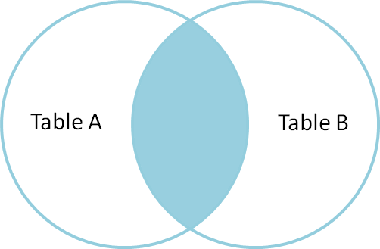

**2.** **Outer Joins** = Outer joins combine everything from both tables together, even if both records do not share a matching value. They can be useful if you need to combine two tables together and want to keep all of the rows, or want a large result set.

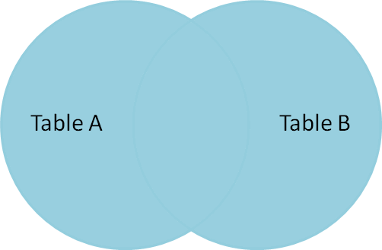

**3.** **Left Joins** = Left joins are a type of outer join that retains all of the records of the left table and include only records from the right table that match the join condition (share a common attribute). Left joins are similar to an inner join in that you are getting all of the related records that both tables share, but all of the left table’s records are included in the result set whether they match the join condition or not.

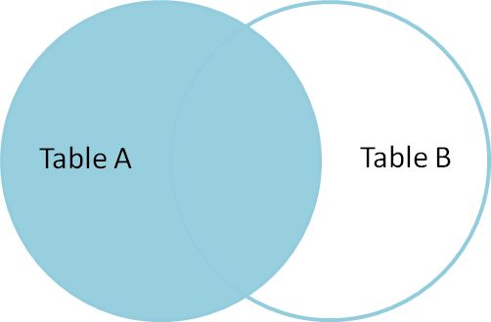

**4. Right Joins** = Right joins are exactly the same as left joins except that all of the records from the right table are retained instead. Records from the left table that match the join condition (share a common attribute) will still be included in the result set as well. Right joins come in handy when the left table may contain NULLS (blanks) in the common field that is being used to join

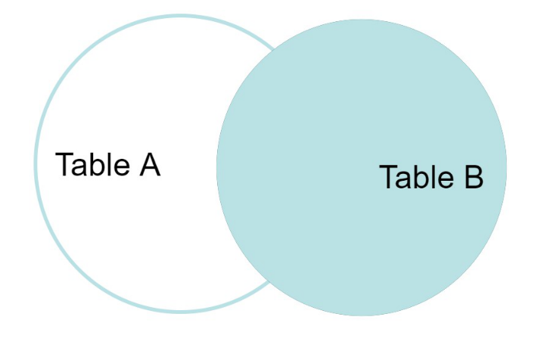

**6) How Many constraint and describes it self?**

• **NOT NULL** – If we specify a field in a table to be NOT NULL. Then the field will never accept null value. That is, you will be not allowed to insert a new row in the table without specifying any value to this field.   
**Example** = the below query creates a table Student with the fields ID and NAME as NOT NULL. That is, we are bound to specify values for these two fields every time we wish to insert a new row.   
**Syntax** = CREATE TABLE Student (ID int(8) NOT NULL,NAME varchar(12) NOT NULL,ADDRESS varchar(15));

• **UNIQUE** – This constraint helps to uniquely identify each row in the table. i.e. for a particular column, all the rows should have unique values. We can have more than one UNIQUE column in a table.  
**Example** = the below query creates a table Student where the field ID is specified as UNIQUE. i.e, no two students can have the same ID. Unique constraint in detail.   
**Syntax** = CREATE TABLE Student(ID int(6) NOT NULL UNIQUE,NAME varchar(10), ADDRESS varchar(20));

• **PRIMARY KEY** - Primary Key is a field which uniquely identifies each row in the table. If a field in a table as primary key, then the field will not be able to contain NULL values as well as all the rows should have unique values for this field. So, in other words we can say that this is combination of NOT NULL and UNIQUE constraints. A table can have only one field as primary key. Below query will create a table named student and specifies the field ID as primary key.   
**Syntax** = CREATE TABLE Student (ID int(6) NOT NULL UNIQUE,NAME varchar(10), ADDRESS varchar(20),PRIMARY KEY(ID));

• **FOREIGN KEY** – Foreign Key is a field in a table which uniquely identifies each row of a another table. That is, this field points to primary key of another table. This usually creates a kind of link between the tables.   
**Example** = it uniquely identifies each row in the Customers table. Therefore, it is a Foreign Key in Order stable.   
**Syntax** = CREATE TABLE Orders (O_ID int NOT NULL,ORDER_NO int NOT NULL,C_ID int,PRIMARY KEY (O_ID),FOREIGN KEY (C_ID) REFERENCES Customers(C_ID))

• **CHECK** – Using the CHECK constraint we can specify a condition for a field, which should be satisfied at the time of entering values for this field.   
**Example** = the below query creates a table Student and specifies the condition for the field AGE as (AGE >= 18 ). That is, the user will not be allowed to enter any record in the table with AGE < 18. **Syntax**: CREATE TABLE Student(ID int(6) NOT NULL,NAME varchar(10) NOT NULL,AGE int NOT NULL CHECK (AGE >= 18));

• **DEFAULT** – This constraint is used to provide a default value for the fields. That is, if at the time of entering new records in the table if the user does.   
**Example** = the below query will create a table named Student and specify the default value for the field AGE as 18.   
**Syntax** = CREATE TABLE Student(ID int(6) NOT NULL,NAME varchar(10) NOT NULL,AGE int DEFAULT 18);

7) **Difference between RDBMS vs DBMS ?**

|  |  |
| --- | --- |
| **RDBMS** | **DBMS** |
| * Stores data in files and directories | * Organizes data into tables with predefined relationships |
| * Supports various data models, including NoSQL. | * Follows a relational data model with tables and rows. |
| * Schema changes may require data migration. | * Allows schema modifications without data migration. |
| * May have proprietary query languages. | * Uses standard SQL (Structured Query Language) for data manipulation. |
| * File systems, MongoDB, SQLite. | * MySQL, PostgreSQL, Oracle, SQL Server, etc. |

**8) What is API Testing?**

* **API Testing** = API is the mediator which helps to applications to communicate with each other. It is kind of logic written by developers using any programming language to perform something. Testing the business logic of any application is called API. QA will test the same logic and called API testing.

**9) Types of API Testing?**

* **Open APIs**: These types of APIs are publicly available to use like OAuth APIs from Google. It has also not given any restriction to use them. So, they are also known as Public APIs.
* **Partner APIs**: Specific rights or licenses to access this type of API because they are not available to the public.
* **Internal APIs**: Internal or private. These APIs are developed by companies to use in their internal systems. It helps you to enhance the productivity of your teams

**10) What is Responsive Testing?**

* **Responsive Testing =** Responsive testing involves how a website or web application looks and behaves on different devices, screen sizes, and resolutions. The goal of responsive testing is to ensure that the website or web application can be used effectively on various devices, including desktops, laptops, tablets, and smartphones.

**11) Which types of tools are available for Responsive Testing?**

* LT Browser   
  Lambda Testing   
  Google Resizer   
  am I responsive   
  Pixel tuner

**12) What is the full form of .ipa, .apk?**

* **.ipa** = International Phonetic Alphabet
* .**apk** = Android Application Package

**13) How to create step for to open the developer option mode ON?**

* **Step 1**: Go to Settings > About phone.  
  **Step 2**: Scroll down to Build number.   
  **Step 3**: Tap Build number seven times. After the first few taps, you should see the steps counting down until you unlock the developer options. You may also have to tap in your PIN for verification.   
  **Step 4**: Once developer options are activated, you will see a message that reads, You are now a developer.   
  **Step 5**: Go back to the Settings pane and head to System, where you will now find Developer options as an entry.   
  **Step 6**: Tap it and toggle the switch on if it is not already, and from there, you can proceed to make adjustments to your phone